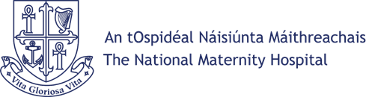 |  |  | FREEDOM OF INFORMATION REQUEST FORM
CONFIDENTIALITY AND DATA USE
The National Maternity Hospital fully respects your right to privacy and confidentiality in relation to your interaction with us. All data and information that you volunteer will be treated with the highest standard of security and confidentiality, strictly in accordance with the Data Protection Act, 2018.
PLEASE COMPLETE THE FORM BELOW AND SEND TO:.
FOI Officer, Medical Records Department, National Maternity Hospital, Holles St., Dublin D02 YH21
Proof of Identity Required
To protect the confidentiality and security of your personal information, all Freedom of Information (FOI) requests for access to your own personal information must be accompanied by proof of identity. please include a copy of one of the following: Passport, Divers License, Public Services Card (back and front)

Please provide one of the following:
Please provide one of the following:

SURNAME:
(when patient of NMH)
FORENAME:
(when patient of NMH)
CURRENT SURNAME:
(if different to present)
HOME ADDRESS:
(when patient of NMH)
CURRENT HOME ADDRESS:
(if different to present)
 | DATE OF BIRTH:
HOSPITAL NUMBER:
(if known)
 | HOME TELEPHONE No.: |  |  | MOBILE No.:
 | DETAILS OF INFORMATION REQUEST:
 | SIGNED: |  |  |  | DATE:

