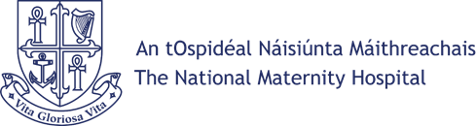
ROUTINE ACCESS REQUEST FORM

CONFIDENTIALITY AND DATA USE

The National Maternity Hospital fully respects your right to privacy and confidentiality in relation to your interaction with us through this Routine Access Request Form. All data and information that you volunteer will be treated with the highest standard of security and confidentiality, strictly in accordance with the Data Protection Act, 2018 and used only for the
intended purpose of seeking to continually improve the quality and safety of our services.

PLEASE COMPLETE THE FORM BELOW AND SEND TO:.
Routine Access, Medical Records Department, National Maternity Hospital, Holles St., Dublin D02 YH21

Proof of Identity Required
To ensure that personal information is only disclosed to the correct individual, the National Maternity Hospital requires proof of identity before processing Access Requests. Please provide one of the following: Passport, Divers License, Public Services Card (back and front)
01. | SURNAME:  (when patient of NMH)
02. | FORENAME:
02. | (when patient of NMH)
03. | CURRENT SURNAME:
03. | (if different to present)
04. | HOME ADDRESS:
04. | (when patient of NMH)
05. | CURRENT HOME ADDRESS:  (if different to present)
06. | DATE OF BIRTH:
07. | HOSPITAL NUMBER:
07. | (if known)
08. | HOME TELEPHONE No.: | MOBILE No.:
09. | DETAILS OF INFORMATION REQUEST:
10. | SIGNED: |  | DATE:

NMH Patient Services Routine Access Request Form 1 Ver.2.0

